GSBS 6003
Globalisation

Group A4

Name: Junxi Ding,
Student ID: c3395297,

Name: Maninder Singh
Student ID: c3437806

Name: Shama Praveen
Student ID: c3470623

Assessment 2: Group Assignment

Table of Contents

Executive summary 2
1.0 Introduction 3
2.0 Economic Analysis 4
2.1 Economic Environment 4
2.1.1 GDP growth rate 4
Figure 1: China and India's GDP growth line graphs (World Bank Open Data, n.d.). 5
2.1.2 Inflation rate 5
Figure 2: Inflation in India and China. (World Bank Open Data, n.d.). 6
3.0 Political and Legal Environment 6
3.1 Political environment 7
3.1.1 Political stability 7
3.1.2 Government policies 7
3.1.3 Regulatory framework 8
4.0 Market Potential and Consumer Behavior 8
4.2 For China 9
6.0 Risk Assessment 11
6.1 Political Risk 11
6.2 Economic Risk 11
6.3 Social Risk 11
6.4 Technological Risk 12
7.0 Entry Strategies 12
7.1 Entry Modes 12
7.1.1 Joint Ventures 12
7.1.2 Acquisitions 12
7.1.3 Strategic Partnerships 13
7.1.4 Wholly Owned Subsidiaries 13
7.2 Market entry barriers 13
7.2.1 Legal Restrictions 13
7.2.2 Competition 13
7.2.3 Cultural barriers 13
7.2.4 Tariff structures 13
7.3 Recommendations 14
7.3.1 For India 14
7.3.2 For China 14
8.0 Financial Analysis 14
8.1 Cost Analysis 14
8.2 Currency Exchange 15
8.3 Financial projections and return on investment (ROI) 15
9.0 Sustainability and Corporate Social Responsibility (CSR) 15
Figure 5: Number of CSR projects in China, 2006-2016. CSMR database 16
Figure 6: Growth of CSR spending in India 16
10.0 Conclusion and Recommendations 18
11.0 References 19

Executive summary
This report provides the Australian Trade Commission with an analysis and comparison of the attractiveness of India and China to Australian companies seeking international expansion and international investment. Four dimensions are analyzed: the political environment, the economic environment, socio-cultural factors and the legal environment. This report analyzes the two countries under the four dimensions, thereby providing a sound comparison and assessment of the business environment in both countries.

The political economy has a huge influence on a country, the law takes responsibility for the business and social environment, and the culture shows the potential and dynamics of social development.

Research and analysis have shown that China comparatively exhibits higher political stability and more predictable regulation than India. However, India exhibits higher growth rates and more favorable ease of doing business indices, and China's authoritarianism in politics may have an impact. On the socio-cultural front, both countries face challenges and opportunities, with China's consumer base being more similar but lacking in diversity and purchasing power for certain goods. India, on the other hand, has greater cultural diversity across regions. Both countries have complex legal environments, with China having better IPR protection mechanisms.

Based on the analysis, both India and China offer some opportunities, but there are also greater risks. It is recommended that Austrade provide advisory services tailored to the specific needs of Australian businesses to minimize the risk of investing in both countries and avoid unnecessary complications.

1.0 Introduction
In today's globalized economy, developing international markets plays an important role in the progress and improvement of Australian companies. The mission of the Australian Trade Commission (Austrade) is to support the international business activities of Australian companies, and it plays a key role in providing advice, market intelligence and support to reduce the risk of investment and improve the economic returns for Australian companies in the international investment environment (Austrade, 2011).

This report provides a comparative analysis of the attractiveness of two countries, India and China, as potential markets for Australian companies seeking to expand internationally. As two of the fastest growing economies in the world, India and China offer significant opportunities for Australian companies to invest internationally, and both countries have large population bases with some purchasing power (World Bank, 2023). However, the two countries also face certain challenges due to their different political, economic, socio-cultural and legal environments (Hill, 2018).

The purpose of this report is to provide some experiences and recommendations for the Australian Trade Commission to help provide some situations and opportunities that Australian companies can refer to when it comes to international expansion. By analyzing key aspects of the business environments in India and China, this report aims to determine which country poses fewer risks and challenges to Australian businesses and is more conducive to investment by Australian companies.

By analyzing political, economic, socio-cultural and legal factors, this report will provide a basic understanding of the business environment in India and China. It also provides certain recommendations with a view to improving the success of Australian business investment.

2.0 Economic Analysis

2.1 Economic Environment
A country's economic environment reflects the country's key to attracting investment from foreign companies. The rate of GDP growth and the amount of inflation all have an impact on the business environment for foreign investors, and also on the potential investment opportunities for foreign investors.

2.1.1 GDP growth rate

Figure 1: China and India's GDP growth line graphs (World Bank Open Data, n.d.).

From the line graph we can see that China's GDP growth rate exceeded India's in the early 2000's, but in recent years India's GDP growth rate has exceeded China's, which could be a sign of accelerated economic development in India. Other than that, the GDP growth of both the countries is in an increasing trend. Even though India produced a negative GDP growth in 2020 due to the epidemic.

China and India's GDPs have been largely growing, reflecting the good state of their markets for foreign investors. At the same time, the growing GDP status also provides more investment opportunities for foreign investors.

2.1.2 Inflation rate

Figure 2: Inflation in India and China. (World Bank Open Data, n.d.).

From the chart we can see that India and China had higher inflation rates after 2000. The International Monetary Fund (IMF) usually targets the inflation rate between 2% and 3%, which is good for the stability of the economy (Jahan, 2012). But higher inflation in India and China may lead to lower consumer purchasing power, price instability and increased economic uncertainty.
However, the governments of India and China have responded positively to the challenges and have achieved some success, and the inflation rate will be on a positive trend in the future, which also presents opportunities and room for foreign investors to invest.
The GDP growth of both countries shows that both countries have the potential for economic development, but the inflation rate still has an impact on the stability of the economy.

3.0 Political and Legal Environment

3.1 Political environment
The political environment of a country plays a crucial role in the attractiveness of its markets to international firms.

3.1.1 Political stability
Political stability is essential for creating a favorable business environment and attracting investment from other countries. According to the World Bank's Global Governance Indicators, which measure countries' perceptions of the quality of governance, China has consistently ranked high in terms of political stability compared to India (Kaufmann & Kraay, 2023). China's relatively centralized political system allows the government to plan for the long term, providing a sense of stability for companies operating in China. However, it is also important to consider the potential risks associated with political change or tensions, especially in an authoritarian system such as China's, which can easily lead to politically motivated wars in the economic

3.1.2 Government policies
The Chinese government has demonstrated a relatively stable pro-business policy to ease the burdens and difficulties of foreign investors in certain investments, and these policies alone include measures such as tax breaks, infrastructure development, and streamlining of bureaucratic procedures for foreign investors in certain areas (UNCTAD, 2021). The Chinese governments recently launched "Made in China 2025" program aims to upgrade China's manufacturing sector as a whole and promote innovation in the manufacturing sector, a measure that demonstrates the government's commitment to economic transformation and technological advancement and has attracted investors from different regions to invest in the Chinese market.
In contrast, India exhibits bureaucratic inefficiencies and a poor business environment, a situation that may adversely affect foreign investors (Alfaro, 2020). However, the Indian government is actively improving the business environment, which demonstrates its commitment to attracting foreign investors.

3.1.3 Regulatory framework
The Chinese government has continued to make progress in improving its regulatory system. Not only has it improved its own system, but in order to attract foreign investment, the Chinese government has also strengthened the protection of IPRs by establishing specialized IPR courts (WIPO, 2021). This has facilitated foreign investors to invest in China.

In contrast, the Indian government's regulatory environment has been criticized for its complexity and inconsistency, particularly with respect to certain issues and gaps in IP protection and contract enforcement (WIPO, 2021). However, the Indian government has begun to simplify unnecessary regulations, which suggests that it is making progress in improving foreign investment.

4.0 Market Potential and Consumer Behavior
4.1 For India
India's population of nearly 1.3 billion people makes it one of the most promising markets in the world. A prominent demographic aspect is its youth, with a sizable share of the population under 35 years old. Furthermore, India is having a growing middle class, but there are huge income discrepancies among regions. While urban areas have better incomes and purchasing power, rural areas provide their own set of opportunities with the rise of aspirational consumers.
India's consumer behavior is a reflection of this variety. There has been a noticeable shift toward e-commerce with the development of digital technologies and increased internet access, especially among urban millennials. This expansion has been accelerated by the accessibility and convenience provided by internet platforms. In addition, increased public health awareness and government initiatives to upgrade healthcare facilities are fueling India's rapidly growing healthcare sector. Consequently, there is a growing need for superior healthcare products and services.

Figure 3: Graphic representation of the population of India and China

4.2 For China
China has the world's highest population, reaching 1.4 billion people. Despite demographic trends caused by the one-child policy, the country continues to have a large customer base. Notably, there is a large aging population, particularly in cities, which brings both opportunities and challenges for enterprises. Income levels vary greatly between areas, with coastal cities showing greater affluence than inland provinces.
China's consumer behavior reflects the nation's fast urbanization and economic growth. The e-commerce industry has grown significantly, led by the dominance of platforms such as Alibaba and JD.com. The ease of use and selection offered by online shopping platforms have altered consumer behavior. In addition, China has established itself as a global leader in renewable energy thanks to large investments in the sector. Australian businesses can benefit from the government's emphasis on environmental sustainability and clean energy in the form of opportunities for renewable energy products and services.

5.0 Competitive Landscape and Opportunities:
The e-commerce business in India and China offers enormous prospects for Australian companies. With rising internet penetration and digital knowledge, people are increasingly resorting to online purchasing platforms. Australian businesses can benefit from this trend by providing innovative products and services suited to local interests.
China's strong clean energy targets make the renewable energy sector an ideal place for collaboration and investment. The country's huge renewable energy capacity, along with supporting government legislation, creates a favorable climate for Australian enterprises seeking to enter this industry. Similarly, India's rising emphasis on renewable energy creates potential for collaboration on solar, wind, and other clean energy technologies.

Both India and China have potential for Australian enterprises to provide new healthcare products and services. India's developing healthcare sector, driven by rising incomes and increased healthcare spending, provides chances for Australian companies to sell medical devices, pharmaceuticals, and healthcare services. Quality healthcare services are in high demand in China, thanks to an aging population and rising health consciousness. Australian businesses can profit on this need by providing innovative medical technologies, telemedicine solutions, and healthcare management services.

6.0 Risk Assessment

6.1 Political Risk
Political hazards exist in both India and China, which can affect commercial operations. Foreign enterprises in India may face uncertainty due to regulatory changes and bureaucratic barriers. The country's democratic political system may lead to policy changes and legislative reforms impacting business settings. Similarly, China's autocratic political environment and centralized decision-making procedures can result in unexpected policy shifts and regulatory crackdowns, posing dangers to foreign investors. Furthermore, geopolitical tensions between India and China, as well as other surrounding nations, may worsen and affect corporate operations.

6.2 Economic Risk
Economic risks are substantial for enterprises working in India and China. Economic slowdowns, currency changes, and inflationary pressures all have an impact on market demand and consumer purchasing power. Both countries are vulnerable to global economic trends and trade conflicts, which can depress company confidence and investment sentiment. Furthermore, structural concerns such as income inequality and differences between urban and rural areas in India, as well as debt levels and financial market instability in China, may heighten economic risks to enterprises.

6.3 Social Risk
Social risks might affect business environments in India and China. Sociocultural factors, such as language limitations and cultural conventions, can make it difficult for international enterprises to engage effectively with local stakeholders and consumers. Furthermore, societal instability, labor disputes, and demographic factors like aging and urbanization may have an impact on labor markets and supply chains. In China, the hukou (household registration) system and rural-urban split may worsen social inequality and spark social tensions.

6.4 Technological Risk
Businesses in China and India can gain from and face obstacles from the rapid advancements in technology. While technological innovation boosts productivity and economic growth, it also upends long-standing company structures and industries. In addition to addressing cybersecurity issues, foreign businesses operating in both nations must protect their intellectual property rights (IPR). Organizations that depend on technology also run the risk of cyberattacks, data breaches, and technological obsolescence. Reducing technical threats requires investing in robust cybersecurity measures and staying up to date with technological advancements.

7.0 Entry Strategies

7.1 Entry Modes
When considering entry into the Indian and Chinese markets, Australian companies must carefully evaluate various entry strategies to determine the most suitable approach. Here’s an analysis of different entry modes and associated market entry barriers:

7.1.1 Joint Ventures
Forming joint ventures with local companies can be advantageous as it allows Australian firms to leverage the knowledge, resources and networks of their local partners.

7.1.2 Acquisitions
Acquiring existing businesses in India and China can provide Australian companies with market access, established customer basis and operational infrastructure.

7.1.3 Strategic Partnerships
Collaborating with local firms or industry partners through strategic alliances can be a cost effective and low risk entry strategy.

7.1.4 Wholly Owned Subsidiaries
It offers full control but entails higher investment and regulatory compliance burdens, best for firms with ample resources and market confidence.

7.2 Market entry barriers
When considering market entry into India and China, Australian companies should be aware of several significant barriers:

7.2.1 Legal Restrictions
Legal Restrictions in sectors like telecommunications and finance necessitate compliance expertise and government liaisons.

7.2.2 Competition
Fierce competition in rapidly evolving markets demands differentiated strategies and strong value propositions.

7.2.3 Cultural barriers
It necessitates sensitivity to local customs, language and business etiquettes to foster trust and rapport.

7.2.4 Tariff structures
Tariffs and trade barriers imposed by the Indian and Chinese governments can impact the cost of importing/exporting goods and services.

7.3 Recommendations
Based on the market conditions in India and China, here are recommendations for the most suitable entry strategies for Australian companies:

7.3.1 For India
Leveraging joint ventures or strategic partnerships could be advantageous, particularly in sectors like IT and renewable energy.

7.3.2 For China
China’s competitive landscape and rapid market evolution may favor a combination of acquisitions and strategic partnerships, especially in technology and healthcare sectors.

8.0 Financial Analysis

8.1 Cost Analysis
Cost Analysis for Australian companies expanding into India and China encompasses various factors. In India, labor costs are relatively lower compared to Australia, making it an attractive destination for outsourcing and manufacturing. However, infrastructure expenses can vary significantly across regions, with urban areas offering better facilities but at higher costs. Tax implications can be complex in India, with different rates and regulations depending on the industry and state.
In China, while labor costs have risen in recent years, they remain competitive compared to Australia. Infrastructure expenses can be high in developed urban centers but relatively lower in inland regions. Tax regulations in China are stringent, with corporate taxes and value added taxes to consider.

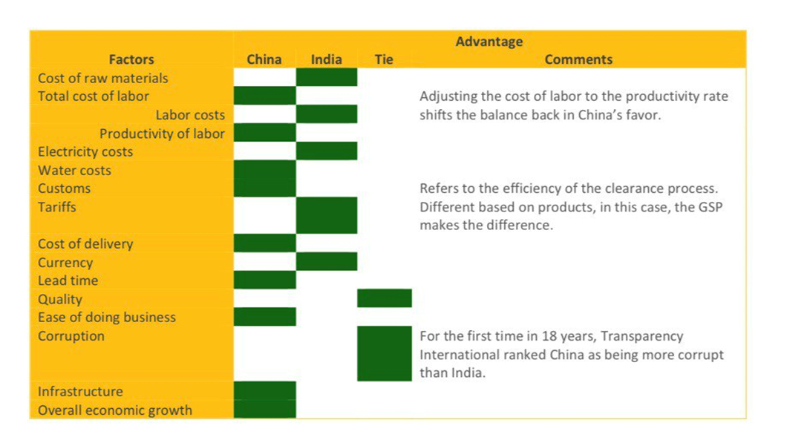
Figure 4: Cost analysis between India and China

8.2 Currency Exchange
Currency Exchange risks are inherent in international business operations. Hedging strategies like forward contracts or options can mitigate these risks. Both India and China offer financial incentives to attract foreign investment such as tax breaks, subsidies or special economic zones.

8.3 Financial projections and return on investment (ROI)
Financial projections for expansion into India and China depend on market research, estimating revenues, expenses and initial investment. ROI compares expected profits to initial investment, crucial for gauging expansion sustainability. Funding options include internal resources, venture capital, bank loans or government grants, tailored to company financials and growth goals.

9.0 Sustainability and Corporate Social Responsibility (CSR)
As people’s knowledge of sustainability issues grows, environmental policies are changing in China and India as well. India has put policies in place to deal with waste management, pollution and the use of renewable energy. China has set high environmental standards as well, launching programs to support renewable energy sources, lower carbon emissions and enhance air quality.

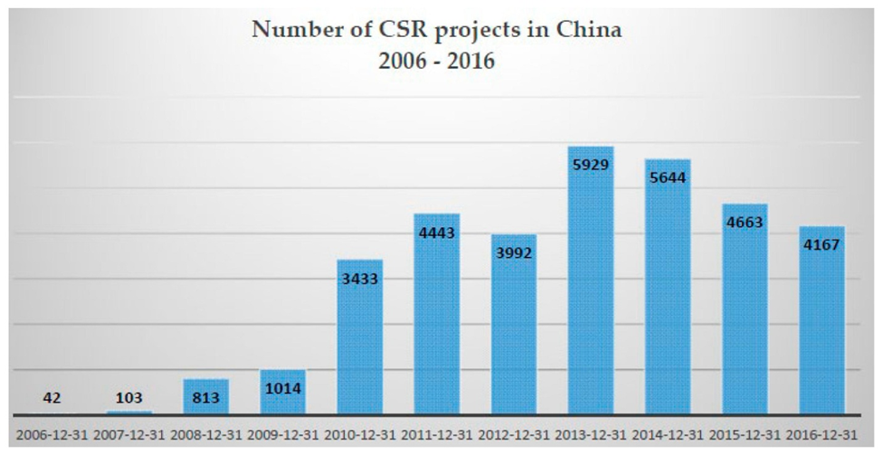

Figure 5: Number of CSR projects in China, 2006-2016. CSMR database

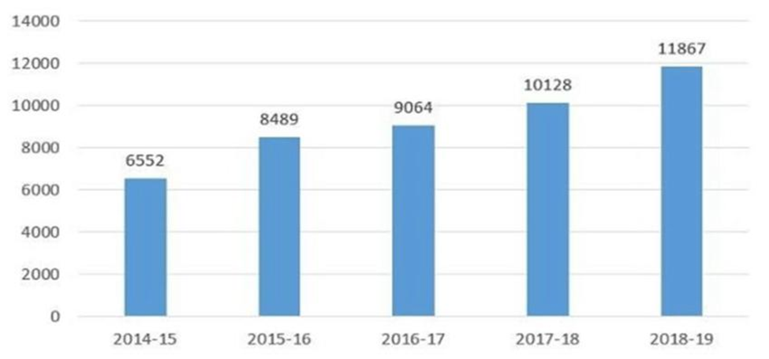

Figure 6: Growth of CSR spending in India

Corporate Social Responsibility (CSR) practices vary in both countries but are gaining importance. Many companies in India and China are incorporating CSR into their operations, focusing on areas like education, healthcare, poverty alleviation and community development.

Enhancing sustainable business practices positively impacts brands reputation, market positioning and consumer trust. Companies demonstrating a commitment to environmental stewardships and social responsibility often enjoy stronger customer loyalty, employee engagement and investor confidence.
To succeed in these markets, Australian companies should integrate CSR into their business strategies. This involves aligning CSR initiatives with stakeholders and transparently communicating CSR efforts. Collaborating with local communities, leveraging technology for sustainable innovation and adopting ethical supply chain practices are also key recommendations. By embracing CSR as a core part of thier business model, Australian companies can foster long term sucess and contribute positively to society in India and China.

10.0 Conclusion and Recommendations
The conclusion of the analysis comparing India and China as potential markets for Australian companies seeking international expansion and investment highlights several key points.

Firstly, both countries offer significant opportunities due to their large consumer bases, growing economies, and government initiatives to attract foreign investment. However, they also present challenges such as political risks, economic fluctuations, socio-cultural differences, and regulatory complexities.

In terms of political stability, China has a more centralized system that provides a sense of long-term stability, while India's democratic setup may lead to policy changes impacting businesses. Both countries are actively improving their business environments, with China focusing on pro-business policies and India addressing bureaucratic inefficiencies.

Economically, both China and India have shown positive GDP growth trends, although India's growth rate has recently surpassed China's. However, high inflation rates in both countries can affect consumer purchasing power and economic stability.

Regarding market potential and consumer behavior, India's diverse population and growing middle class offer opportunities across various sectors like e-commerce, healthcare, and renewable energy. China, with its large aging population and emphasis on renewable energy, presents opportunities in sectors like clean energy technologies and e-commerce.

The risk assessment highlights political, economic, social, and technological risks that companies need to consider when entering these markets. Strategies such as joint ventures, acquisitions, strategic partnerships, and wholly owned subsidiaries can be tailored based on market entry barriers and opportunities in each country.
Overall, while both India and China offer promising opportunities for Australian companies, thorough market research, risk assessment, and tailored entry strategies are essential for successful international expansion and investment.

11.0 References
About Austrade | Austrade. (2011). www.austrade.gov.au. Retrieved February 1, 2024, from https://www.austrade.gov.au/en/about-austrade
Alfaro, L. (2020). Doing Business: External Panel Review. The World Bank Group.
Hill, C. W. L., & M, T. (2018). International Business : Competing in the Global Marketplace. Mcgraw-Hill Education.
Kaufmann, D., & Kraay, A. (2023). Worldwide Governance Indicators. World Bank. https://www.worldbank.org/en/publication/worldwide-governance-indicators
UNCTAD. (2021). World Investment Report 2021. UNCTAD. https://unctad.org/publication/world-investment-report-2021
Wipo. (2021). GLOBAL INNOVATION INDEX 2021 : tracking innovation through the covid-19 crisis. World Intellectual Proper.
World Bank. (2023). GDP (current US$). The World Bank. https://data.worldbank.org/indicator/NY.GDP.MKTP.CD
World Bank Open Data. (n.d.). World Bank Open Data. Retrieved April 11, 2024, from https://data.worldbank.org/indicator/NY.GDP.DEFL.KD.ZG?end=2022&locations=CN-IN&start=2000
Jahan, S. (2012). Inflation Targeting: Holding the Line. Imf.org. https://www.imf.org/external/pubs/ft/fandd/basics/target.htm

Figures Figure 7: World Bank Open Data. (n.d.).
World Bank Open Data. (n.d.). World Bank Open Data. Retrieved April 11, 2024, from https://data.worldbank.org/indicator/NY.GDP.MKTP.KD.ZG?contextual=default&end=2022&locations=CN-IN&start=2000&view=chart
Figure 8: World Bank Open Data. (n.d.).

World Bank Open Data. https://data.worldbank.org/indicator/NY.GDP.DEFL.KD.ZG?end=2022&locations=CN-IN&start=2000
Administration, I. T. (2022, 07 19). Australia Country Commercial Guide. international trade administration. https://www.trade.gov/country-commercial-guides/australia-market-entry-strategy
Administration, I. T. (2023, 04 07). China Country Commercial Guide. International Trade Administration. https://www.trade.gov/country-commercial-guides/china-market-entry-strategy
Anil K. Gupta, & Haiyan Wang. (2009, 02 24). The China and India Strategy. strategy business. https://www.strategy-business.com/article/09113
Babu, Aleena, Eldho, Elja, Chandramana, Sudeep, & T M, Abhishek. (2020, nov). CORPORATE SOCIAL RESPONSIBILITY PRACTICES AMONG INDIAN COMPANIES DURING COVID-19 PANDEMIC PERIOD. ResearchGate. https://www.researchgate.net/figure/Growth-of-CSR-spending-in-India_fig1_346654412
Hiten Shah , & Alina Harastasan. (2015, october). China vs. India. A Sourcing Experience. . mesinct.net. chrome-extension://efaidnbmnnnibpcajpcglclefindmkaj/https://www.mesinc.net/wp-content/uploads/2015/11/MES-White-Paper-Series-China-vs.-India.-A-Sourcing-Experience.pdf
India Country Commercial Guide. (n.d.). Privacy Shield framework. https://www.privacyshield.gov/ps/article?id=India-market-entry-strategy
KUN LI, Nasrin R. Khalili, & Weiquan Cheng. (2019, 01 11). Corporate Social Responsibility Practices in China: Trends, Context, and Impact on Company Performance. MDPI. https://www.mdpi.com/2071-1050/11/2/354
Reckmann, N. (2023, september 05). What Is Corporate Social Responsibility? business news daily. https://www.businessnewsdaily.com/4679-corporate-social-responsibility.html
Shira, D. (2020, march 23). Corporate Social Responsibility in India. indian briefing. https://www.india-briefing.com/news/corporate-social-responsibility-india-5511.html/
Sugiura, A., & Holder, S. (2024, 04 10). As India's GDP growth speeds up, can it drive the global economy? business standrad. https://www.business-standard.com/amp/economy/news/will-india-be-world-s-next-growth-driver-as-its-economic-growth-speeds-up-124041000282_1.html?isa=yes
(3rd October 2017) Australian Wine in China https://www.wineaustralia.com/whats-happening/stories-of-australian-wine/october-2017/china-awards-2017

Juana caballera and marco Fengler, (14th April 2023),The future of global consumer market,
https://www.brookings.edu/articles/china-and-india-the-future-of-the-global-consumer-market/

